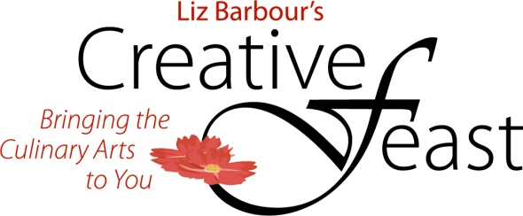
www.thecreativefeast.com

Art of the Pie® Best Old Fashioned Apple Pie
Kate McDermott-Art of the Pie®

About 10 cups heritage apples skin on, quartered and cored.
1/2 cup flour
1/2 cup sugar
1/2 teaspoon salt
1 teaspoon cinnamon
2 gratings nutmeg
1/2 teaspoon allspice
1 tablespoon of an artisan style cider vinegar or fresh squeezed lemon juice
1 tablespoon apple liqueur like Calvados or Caramel Apple optional
1-2 teaspoons butter chopped into little pieces
1 recipe double crust pie dough

For the Egg Wash
1 egg white mixed with 2 T of water
- Slice apples in 1/2 inch slices or chunk them up into pieces you can comfortably get into your mouth!
- In a large mixing bowl put all ingredients except butter and mix lightly until most of the surfaces are covered.
- Pour into an unbaked pie crust, mounding high and dot with butter.
- Roll out second crust and place on top; crimp edges with a fork.
- Cut vent holes.
- Paint with egg white wash.
- Sprinkle some extra sugar evenly on top.
- Pre-heat oven to 425F and bake for 20 minutes.
- Reduce heat to 375F and bake for 40 minutes longer.
- Remove from the oven and cool for at least 1 hour.

Heritage or Heirloom Apples are those that are regional to specific areas and are many times grown by small farmers and then brought to farmers markets. You can also use a good mix of apples from your local grocery. I like to use both sweet and tart apples in a pie for flavor. If peels bother you, remove them.

